QUALIFIED END-USER (SOLAR GENERATION FACILITY)
Name of Owner/QE
Name of Facility, if applicable
Distribution Utility (DU) | ILOCOS NORTE ELECTRIC COOPERATIVE, INC.
Generation Facility Address | Lot/Block/Phase | Street Name | Barangay / Subdivision
Generation Facility Address | Municipality/City | Province | Zip Code
Generation Facility Address |  | ILOCOS NORTE
Number of Units (no. of modules/solar panels and inverters) |  | Number of inverters

TECHNICAL SPECIFICATION (SOLAR)
PARTICULARS | Unit No. 1 | Unit No. 2 | Unit No. 3 | Unit No. 4
Installation Date
Test and Commissioning Date
Economic Life
INVERTER
Year Manufactured
Manufacturer
Serial Number
Rated Capacity (kW)
Dependable Capacity (kW)
Voltage (V)
Frequency (Hz)
MODULES / SOLAR PANEL
Manufacturer
No. of Solar Panels Connected
Rated Capacity per panel (W_{P})
Aggregated Rated Capacity per Inverter (kW_{P})
Note: Please provide additional sheet(s) if necessary
PERSON WHO PROVIDED THE ABOVE INFORMATION
Name |  | Designation
Date Accomplished
Government Issued Identification Card No.
Date Issued |  | Place Issued
Signature | 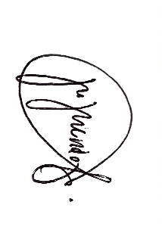

Indicate Actual Date of Installation of the Facility
Indicate Actual Date of Test and Commissioning (from start to end of Test and Commissioning)

